Blood Analysis

1. G=ABCDEF, resolution is VII

2. 7=3+4, the highest interaction we should look for is 3

3. analyze S versus all main effects and 2 way interactions, we have:

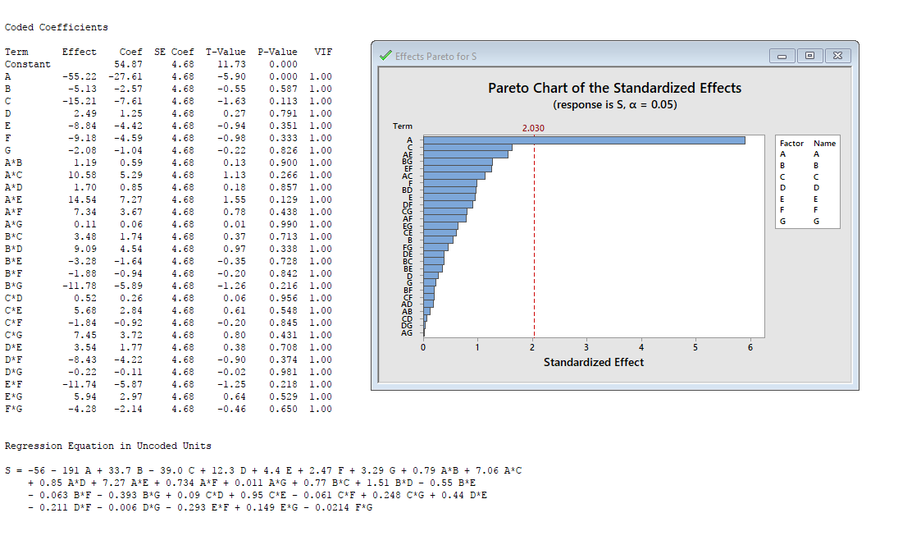

A is the factor that affects the variation.

analyze S versus A, we have:

Coded Coefficients

Term Effect Coef SE Coef T-Value P-Value VIF

Constant 54.87 4.26 12.89 0.000

A -55.22 -27.61 4.26 -6.49 0.000 1.00

Regression Equation in Uncoded Units

S = 137.7 - 55.22 A

we have to maximize A, substrate type (A=2), to reduce the variance

4. analyze Y versus all main effects, 2 way and 3 way interactions, we have:

Coded Coefficients

Term Effect Coef SE Coef T-Value P-Value VIF

Constant 1059.05 5.05 209.73 0.000

A 2.58 1.29 5.05 0.26 0.799 1.00

B 314.59 157.30 5.05 31.15 0.000 1.00

C 593.43 296.71 5.05 58.76 0.000 1.00

D -9.28 -4.64 5.05 -0.92 0.360 1.00

E 150.84 75.42 5.05 14.94 0.000 1.00

F -13.21 -6.61 5.05 -1.31 0.193 1.00

G -4.97 -2.49 5.05 -0.49 0.623 1.00

A\*B 0.84 0.42 5.05 0.08 0.934 1.00

A\*C 3.97 1.99 5.05 0.39 0.695 1.00

A\*D 17.98 8.99 5.05 1.78 0.077 1.00

A\*E -3.74 -1.87 5.05 -0.37 0.712 1.00

A\*F 12.15 6.08 5.05 1.20 0.231 1.00

A\*G 3.07 1.54 5.05 0.30 0.761 1.00

B\*C 74.82 37.41 5.05 7.41 0.000 1.00

B\*D 11.70 5.85 5.05 1.16 0.249 1.00

B\*E -1.30 -0.65 5.05 -0.13 0.898 1.00

B\*F 7.74 3.87 5.05 0.77 0.445 1.00

B\*G 13.09 6.55 5.05 1.30 0.197 1.00

C\*D -7.30 -3.65 5.05 -0.72 0.471 1.00

C\*E -11.01 -5.50 5.05 -1.09 0.278 1.00

C\*F -1.57 -0.79 5.05 -0.16 0.877 1.00

C\*G 3.31 1.66 5.05 0.33 0.743 1.00

D\*E -4.38 -2.19 5.05 -0.43 0.665 1.00

D\*F -5.71 -2.85 5.05 -0.56 0.573 1.00

D\*G -1.97 -0.98 5.05 -0.19 0.846 1.00

E\*F -3.95 -1.97 5.05 -0.39 0.696 1.00

E\*G 3.73 1.86 5.05 0.37 0.713 1.00

F\*G -34.01 -17.01 5.05 -3.37 0.001 1.00

A\*B\*C 3.17 1.58 5.05 0.31 0.754 1.00

A\*B\*D -6.53 -3.26 5.05 -0.65 0.519 1.00

A\*B\*E 5.72 2.86 5.05 0.57 0.572 1.00

A\*B\*F -13.80 -6.90 5.05 -1.37 0.174 1.00

A\*B\*G -19.77 -9.89 5.05 -1.96 0.052 1.00

A\*C\*D 4.09 2.04 5.05 0.40 0.686 1.00

A\*C\*E 10.49 5.25 5.05 1.04 0.301 1.00

A\*C\*F -1.51 -0.76 5.05 -0.15 0.881 1.00

A\*C\*G 11.98 5.99 5.05 1.19 0.238 1.00

A\*D\*E 4.28 2.14 5.05 0.42 0.673 1.00

A\*D\*F 4.12 2.06 5.05 0.41 0.684 1.00

A\*D\*G -6.05 -3.03 5.05 -0.60 0.550 1.00

A\*E\*F -4.52 -2.26 5.05 -0.45 0.656 1.00

A\*E\*G 7.85 3.92 5.05 0.78 0.439 1.00

A\*F\*G 24.62 12.31 5.05 2.44 0.016 1.00

B\*C\*D 1.43 0.72 5.05 0.14 0.888 1.00

B\*C\*E 4.30 2.15 5.05 0.43 0.671 1.00

B\*C\*F -3.43 -1.72 5.05 -0.34 0.734 1.00

B\*C\*G -10.55 -5.27 5.05 -1.04 0.298 1.00

B\*D\*E 9.83 4.92 5.05 0.97 0.332 1.00

B\*D\*F 4.20 2.10 5.05 0.42 0.678 1.00

B\*D\*G 13.19 6.59 5.05 1.31 0.194 1.00

B\*E\*F 21.72 10.86 5.05 2.15 0.033 1.00

B\*E\*G 7.66 3.83 5.05 0.76 0.450 1.00

B\*F\*G -0.10 -0.05 5.05 -0.01 0.992 1.00

C\*D\*E 8.37 4.19 5.05 0.83 0.409 1.00

C\*D\*F -7.98 -3.99 5.05 -0.79 0.431 1.00

C\*D\*G -12.77 -6.38 5.05 -1.26 0.208 1.00

C\*E\*F -12.17 -6.08 5.05 -1.20 0.231 1.00

C\*E\*G 1.26 0.63 5.05 0.12 0.901 1.00

C\*F\*G -0.37 -0.18 5.05 -0.04 0.971 1.00

D\*E\*F 12.47 6.24 5.05 1.23 0.219 1.00

D\*E\*G -5.87 -2.93 5.05 -0.58 0.562 1.00

D\*F\*G -2.17 -1.09 5.05 -0.22 0.830 1.00

E\*F\*G -2.18 -1.09 5.05 -0.22 0.829 1.00

assume alpha is 0.01, we reduce the terms to B,C,E,F,G,BC,FG

analyze Y with the reduced terms, we have:

Coded Coefficients

Term Effect Coef SE Coef T-Value P-Value VIF

Constant 1059.05 4.89 216.51 0.000

B 314.59 157.30 4.89 32.16 0.000 1.00

C 593.43 296.72 4.89 60.66 0.000 1.00

E 150.84 75.42 4.89 15.42 0.000 1.00

F -13.21 -6.61 4.89 -1.35 0.178 1.00

G -4.97 -2.49 4.89 -0.51 0.612 1.00

B\*C 74.82 37.41 4.89 7.65 0.000 1.00

F\*G -34.01 -17.01 4.89 -3.48 0.001 1.00

Regression Equation in Uncoded Units

Y = -1615 + 46.67 B + 98.1 C + 37.71 E + 14.64 F + 18.46 G + 16.63 B\*C - 0.1701 F\*G

when target is 1570, we have:

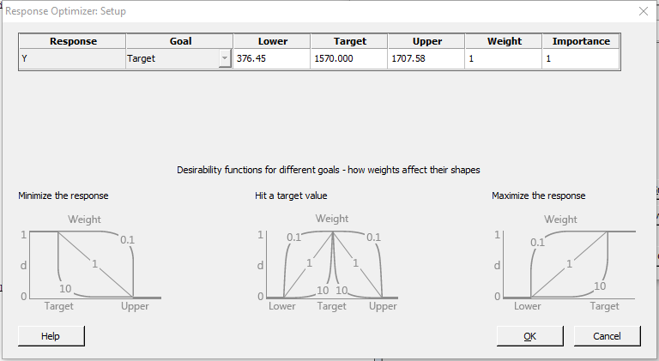

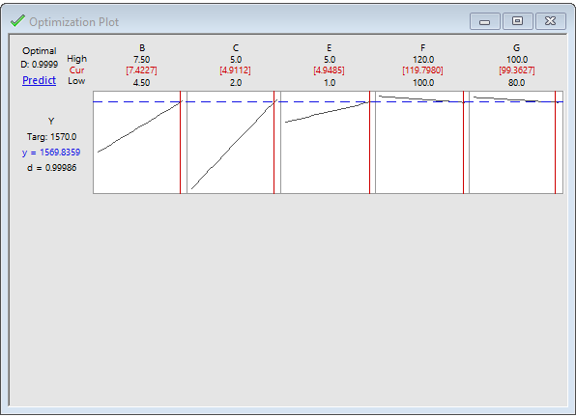

in SimWare Pro, set:

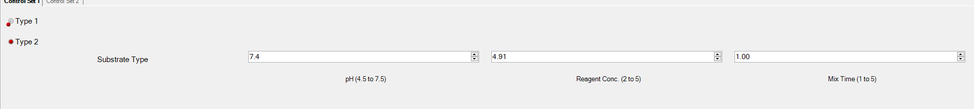

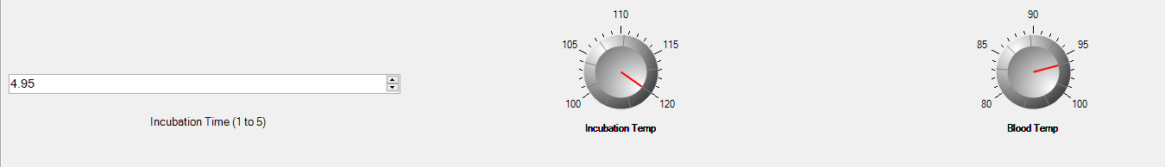

we have:

